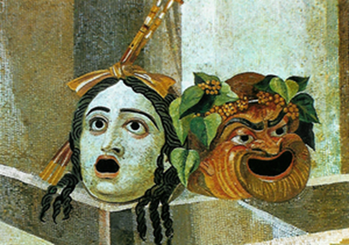
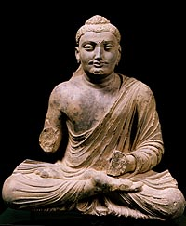
Ghandhara Buddha Roman Theatrical Masks

Classical Indian architecture reflected the religious and cultural values of Hindu society.

2.1. V. Artistic expressions, including literature and drama, architecture, and sculpture, show distinctive cultural developments.

