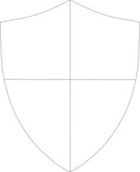
Directions: Pick one of the Mesoamerican civilizations we studied today and create a Coat of Arms for the civilization. Each square should include bulleted information about the civilizations. Your Coat of Arms should include information concerning the religion, government, achievements and your knowledge/prediction of the decline of the civilization.

